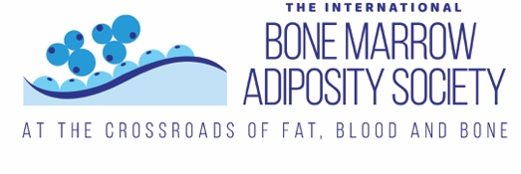

BMAS-IFMRS Future Global Leaders Award
Bone Marrow Adiposity Society welcomes candidates from Low and Middle Income Countries for the BMAS-IFMRS Future Global Leaders Award that will provide free registration to the second edition of the BMAS Summer School 2023, a virtual meeting that will be held on 4-6th September 2023. More info can be found at https://bma-society.org/summer-school-2023/.
This 3-half day event is addressed to all Early Career Researchers (Students, Postdocs, PIs) that are interested about Bone Marrow Adiposity.
The meeting includes scientific lectures and career development workshops, with an amazing panel of speakers. Check the program https://bma-society.org/summer-school-2023-program/.
BMAS, in collaboration with IFMRS, is launching applications for the Future Global Leaders Award, that will provide free registration to BMAS Summer School 2023.
Ten successful applicants from Low and Middle Income Countries will be selected based on the quality of their responses to the criteria in their cover letter.

How to apply
We ask you to prepare a cover letter, following the instruction in the application form below. Abstracts are welcome but not mandatory for these awards.

Deadline
The deadline for applications is 31 July 2023.
For more info contact biagio.palmisano@uniroma1.it

We look forward to seeing you at the BMAS Summer School 2023!

Future Global Leaders Award Application Form

Please email your application to: bmas_summerschool@biomed.cas.cz and biagio.palmisano@uniroma1.it
Applicant information
First name
Last name
Affiliation
Email address
Title (Master, PhD student, Postdoc, etc.)
Are you currently a BMAS member? | Yes No
Do you intend to present an abstract? | Yes No
Abstract details
Title
Authors (insert all authors here)
Authors’ affiliations
Keywords (max 5)
Text (max 300 words):
Aim
Methods
Results
Conclusion

Do you want your abstract published? Yes No

Cover letter
Brief description of you and your project (max 100 words).

How will attending the BMAS summer school help you to achieve your career goals? (max 100 words).

